10X Super Engaged Post Lead Generation Examples

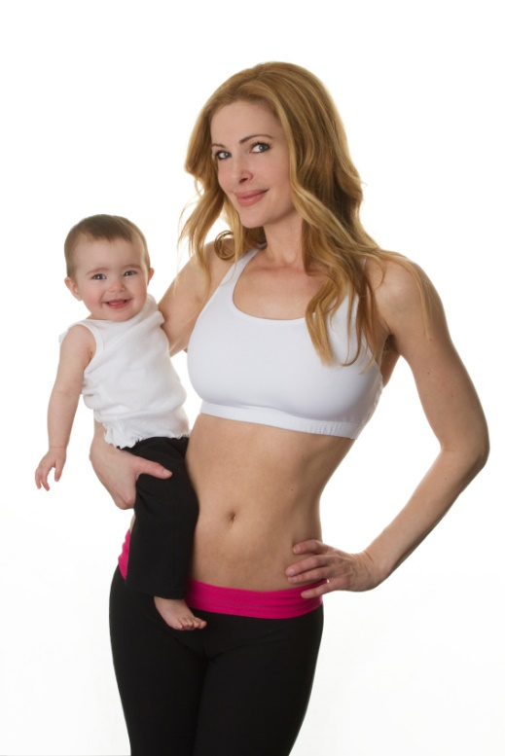
For Busy MOMS ONLY!
I am looking for 8 mom's that fit the following criteria to undergo a Transformation Program to get back in shape and to get their health on track.
http://bit.ly/1CeF091
-Age 29 to 55
-15-40 pounds of fat to lose
-want to drop 1-2 dress sizes
Serious inquiry only. 8 spots only.
Apply Here > http://bit.ly/1CeF091

On back end of facebook (create ad=boost your post= page post engagement= select the post you just made on your business page)

Targeting

United States

Women
Aged 29-55 Demographics- parents


For Brides ONLY:
We are looking for 10 Brides that fit the following criteria to undergo a Transformation
Program to get in shape and to get their health on track.>http://bit.ly/11zUGZw
-Age 23-45 years old
-With 10-50 lbs of Fat to Lose
-Want to drop 1-2 dress sizes
Serious inquiries only.10 spots left.
Apply Here > http://bit.ly/11zUGZw

On back end of facebook (create ad=boost= page post engagement)

Targeting

United States

women
Aged 23-45
Engaged



For Dads ONLY:
We are looking for 6 Dads that fit the following criteria to undergo a Transformation
Program to get in shape and to get their health on track.>https://lifefuelfit.wufoo.com/forms/ultimate-weight-loss-transformation-program/
-Age 29-55 years old
-With 10-50 lbs of Fat to Lose
-Want to drop 1-2 waist sizes
Serious inquiries only.6 spots left.
Apply Here > https://lifefuelfit.wufoo.com/forms/ultimate-weight-loss-transformation-program/

On back end of facebook (create ad=boost= page post engagement)

Targeting

United States

Men

Parents
Aged 29-55

Facebook AD Tips
*Keep in mind these are examples that I have used, but you can also target different demographics. My main goal is to teach you how to use targeted ads to get consistent leads for your business.
*Use Google Images to test out different images that are the IDEAL of your target customer
*Facebook acts funny sometimes and they will approve one ad, then disapprove the same exact ad another day. Always email them to ask why it was disapproved, then make another ad.
*The audience size of your ad is crucial. The more people that you target, the more leads you will get. I focus on 500k and above audience size.
*Testing is vital. Once you get an ad that converts, you can go into into "create similar ad" and focus more different demographics.
Example
*income qualifications ex. 50k, 100k, 125k +

